PRELIMINARY EVIDENCE OF AN INVESTIGATION REQUEST IN THE CONTEXT OF EXTENDING THE IMPOSITION OF TRADE SECURITY MEASURES ON THE IMPORT OF GOODS

CARPETS AND OTHER FLOOR COVERING TEXTILES WHICH ARE INCLUDED IN THE TARIFF POST CHAPTER 57 IN ACCORDANCE WITH THE INDONESIAN CUSTOMS TARIFF BOOK  
2022

UNSECRET

SUBMITTED BY

INDONESIAN TEXTILE ASSOCIATION (API) IN 2023

A. GENERAL

In connection with the imminent end of the implementation of the *imposition of Trade Safeguard Measures based on the* Minister of Finance Regulation (PMK) Number 10/PMK.010/2021 concerning the Imposition of Import Duties on Security Measures on Imports of Carpet Products and Other Floor Covering Textiles, and considering that there are still many similar or directly competing imported products that have an impact on hampering the recovery of serious losses and affect not yet Optimal implementation of structural adjustments in an effort to increase competitiveness with similar imported products.

In this case, the Indonesian Textile Association, or abbreviated as API hereinafter referred to as the Applicant, represents 3 (three) API member companies as the Domestic Industry (IDN) producing carpets and other floor covering textiles, namely PT. Universal Carpet And Rugs, PT. Classic Prima Carpet Industries and PT. Anugerah Esa Mulia hereby submits an application for an investigation of Trade Security *Measures (Safeguard* Measures) to the Indonesian Trade Security Committee (KPPI) in order to be applied to the extension of the imposition of Trade Security Measures in the form of Import Duties on Security Measures (BMTP) on imports of carpets and other floor covering textiles.

To support the application that we submitted, the completeness of the initial evidence of the application has been prepared and supported by the required documents in accordance with the provisions of Government Regulation Number 34 of 2011 (PP 34/2011) concerning Antidumping Measures, Compensation Measures and Trade Security Measures and Decree of the Minister of Industry and Trade of the Republic of Indonesia Number 85 of 2003 (Kepmenperindag 85/2003) concerning Procedures and Requirements for Requesting Investigation of Security Domestic Industry from Due to Surge in Imports.

B. APPLICANT

|  |  |
| --- | --- |
| Name | : Indonesian Textile Association (API) represent 3 (three)  API member companies as IDN, namely PT. Universal Carpet And Rugs, PT. Classic Prima Carpet Industries and PT. Esa Mulia Award |
| Address | : Graha Surveyor Indonesia lt. 16, Jl. Gatot Subroto Kav. 56,  South Jakarta |
| Tel./Fax.  *E-mail*  *Website*  Chairman  *Contact Person*  *Position* | : 021 - 5272171 / 021 - 5272166  : [sekretariat@bpnapi.org](mailto:sekretariat@bpnapi.org)  : -  : Jemmy Kartiwa Sastraatmja  : *Andrew Purnama*  *: Secretary General* |

**The list of IDN names and addresses represented by the Applicant in this application is as follows:**

|  |  |
| --- | --- |
| **1.** Name | :PT. Universal Carpet And Rugs |
| Address | : Gunung Putri Highway No. 285B Tlajung Udik Village, Gunung Putri District, Bogor Regency |
| Email | : [ucrugs@universalcarpets.com](mailto:ucrugs@universalcarpets.com) |
| Tel/Fax | : 021-8677777 / 021-8671727 |
| **2.** Name | :PT. Classic Prima Carpet Industries |
| Address | : Jl. Rungkut Industri II/39 - Surabaya |
| Email | : [classic@cpci.co.id](mailto:classic@cpci.co.id) |
| Tel/Fax | : 031-8438331 / 031-8439085 |
| **3.** Name | :PT. Esa Mulia Award |
| Address | : Jl. Pekapuran RT 001, RW 006, Kel. Pabuaran Kec. Cibinong. Bogor District |
| Email | : [anoop@anugrahesamulia.com](mailto:anoop@anugrahesamulia.com) |
| Tel/Fax | : 021-65302735 / 021-653027 |

1. **PROPORTION OF APPLICANT'S PRODUCTION**

Table 1. Total Production and Proportion of Production Tahun 2022

|  |  |
| --- | --- |
| **Description** | **Proportion (%)** |
| PT. Universal Carpet And Rugs | 45,72 |
| PT. Classic Prima Carpet Industries | 22,56 |
| PT. Esa Mulia Award | 2,09 |
| **Applicant Production** | **70,36** |
| **Non-Applicant Production** | **29,64** |
| **National Production** | **100** |

Note: Convert 1 ton = 633 meters2

Source: Association and Applicant member data

The total production of the Applicant in 2022 is 70.36% of the total national production.

Based on the data in table 1 above, this is in accordance with the provisions of Government Regulation (PP) 34 of 2011 concerning Anti-Dumping Measures, Subsidy Measures, and Trade Security Measures Chapter I Article I paragraph 18, where the Applicant's production constitutes a large proportion of the overall production of carpets and other floor covering textiles in Indonesia, thus qualifying as IDN in terms of Security Measures.

We need to inform you of some changes that have occurred since the issuance of PMK Number 10/PMK.010/2021. In 2021, one of the previous applicants, PT. Velvet Tekstil Indonesia has stopped operating since September 2021 due to a flood of imported products that hinder the development of the domestic carpet industry while PT. Admiralindo Bintang Terang has ceased commercial operations since October 2021 due to accumulated heavy losses over several years. This is due to the influx of imported goods that flood the Indonesian market. This loss was too heavy for the company to continue operations.

1. **ITEMS FOR WHICH AN EXTENSION INVESTIGATION IS APPLIED**
2. Item Description

The items for which the extension investigation application is filed are **Carpets and other floor covering textiles** with 64 (sixty-four) Harmonized System (HS) numbers 8 digits, namely: 5701.10.10, 5701.10.90, 5701.90.11,

* + 1. .19, 5701.90.20, 5701.90.91, 5701.90.99, 5702.10.00, 5702.20.00,
    2. .00, 5702.32.00, 5702.39.10, 5702.39.20, 5702.39.90, 5702.41.10,

|  |  |  |  |  |  |
| --- | --- | --- | --- | --- | --- |
| 5702.41.90, | 5702.42.10, | 5702.42.90, | 5702.49.11, | 5702.49.19, | 5702.49.20, |
| 5702.49.91, | 5702.49.99, | 5702.50.10, | 5702.50.20, | 5702.50.90, | 5702.91.10, |
| 5702.91.90, | 5702.92.10, | 5702.92.90, | 5702.99.11, | 5702.99.19, | 5702.99.20, |
| 5702.99.91, | 5702.99.99, | 5703.10.10, | 5703.10.20, | 5703.10.30, | 5703.10.90, |
| 5703.21.00, | 5703.29.10, | 5703.29.90, | 5703.31.00, | 5703.39.10, | 5703.39.90, |
| 5703.90.11, | 5703.90.19, | 5703.90.21, | 5703.90.22, | 5703.90.29, | 5703.90.91, |
| 5703.90.92, | 5703.90.93, | 5703.90.99, | 5704.10.00, | 5704.20.00, | 5704.90.00, |

5705.00.11, 5705.00.19, 5705.00.21, 5705.00.29, 5705.00.91, 5705.00.92 and

5705.00.99 based on the Indonesian Customs Tariff Book (BTKI) Year 2022

with table 2 as below:

**Table 2: Description of Items Submitted for Investigation**

**Extension**

|  |  |  |
| --- | --- | --- |
| **Number** | **HS Code** | **Item Description** |
| 1 | 5701.10.10 | Carpets and other floor-covering textiles, knitted, finished or not; Rug for prayer from wool or fine animal hair |
| 2 | 5701.10.90 | Carpets and other floor-covering textiles, knitted, finished or not; In addition to rug for prayer from wool or fine animal hair |
| 3 | 5701.90.11 | Carpets and other floor-covering textiles, knitted, finished or not; Cotton rug for prayer |
| 4 | 5701.90.19 | Carpets and other floor-covering textiles, knitted, finished or not; In addition to rug for prayer from cotton |
| 5 | 5701.90.20 | Carpets and other floor-covering textiles, knitted, finished or not; from jute fiber |
| 6 | 5701.90.91 | Carpets and other floor-covering textiles, knitted, finished or not; Rug for prayer; Aside from jute fiber and other than cotton fiber |
| 7 | 5701.90.99 | Carpets and other floor-covering textiles, knitted, finished or not; In addition to the rug for prayer; Aside from jute fiber and other than cotton fiber |
| 8 | 5702.10.00 | Carpets and other floor covering textiles, woven, not tufted or not flock-shaped, finished or not; "Kelem", "Schumacks", "Karamanie" and such hand-woven rug |
| 9 | 5702.20.00 | Carpets and other floor covering textiles, woven, not tufted or not flock-shaped, finished or not; Coconut fiber floor covering (coir); |
| 10 | 5702.31.00 | Carpets and other floor covering textiles, woven, not tufted or flock-shaped; With  Fur construction from wool or fine animal fur is not yet finished |

|  |  |  |
| --- | --- | --- |
| 11 | 5702.32.00 | Carpets and other floor covering textiles, woven, not tufted or flock-shaped; With  Fur construction from artificial textile materials is not finished yet |
| 12 | 5702.39.10 | Carpets and other floor covering textiles, woven, not tufted or flock-shaped; With  fur construction from cotton ; Not finished yet |
| 13 | 5702.39.20 | Carpets and other floor covering textiles, woven, not tufted or flock-shaped; With  fur construction of jute fibers ; Not finished yet |
| 14 | 5702.39.90 | Carpets and other floor covering textiles, woven, not tufted or not flock-shaped;By feather construction; Apart from cotton and apart from jute fiber ; Not finished yet |
| 15 | 5702.41.10 | Rug for prayer, weaving, not tufted or not formed flock; With the construction of fur from wool or fluff of finished animals |
| 16 | 5702.41.90 | Carpets and other floor covering textiles, woven, not tufted or flock-shaped; In addition to the rug for prayer; With feather construction; from wool or fine animal fur ; ready-made |
| 17 | 5702.42.10 | Rug for prayer, weaving, not tufted or not formed flock; Rug for prayer; With fur construction from artificial textile materials; ready-made |
| 18 | 5702.42.90 | Carpets and other floor covering textiles, woven, not tufted or flock-shaped; In addition to the rug for prayer; With fur construction from artificial textile materials; ready-made |
| 19 | 5702.49.11 | Rug for prayer, weaving, not tufted or not formed flock; With the construction of feathers from cotton; ready-made |
| 20 | 5702.49.19 | Carpets and other floor covering textiles, woven, not tufted or flock-shaped; In addition to the rug for prayer; With the construction of feathers from cotton; ready-made |
| 21 | 5702.49.20 | Carpets and other floor covering textiles, woven, not tufted or flock-shaped; With feather construction from jute fibers; ready-made |
| 22 | 5702.49.91 | Rug for prayer, weaving, not tufted or not formed flock; With fur construction apart from cotton and in addition to jute fiber; ready-made |
| 23 | 5702.49.99 | Carpets and other floor covering textiles, woven, not tufted or flock-shaped; In addition to the rug for prayer; With fur construction apart from cotton and in addition to jute fiber; ready-made |
| 24 | 5702.50.10 | Carpets and other floor covering textiles, woven, not tufted or flock-shaped; Not with feather construction; From cotton; Not finished yet |
| 25 | 5702.50.20 | Carpets and other floor covering textiles, woven, not tufted or flock-shaped; Not with feather construction; From jute fiber; Not finished yet |
| 26 | 5702.50.90 | Carpets and other floor covering textiles, woven, not tufted or flock-shaped; Not with feather construction; Aside from cotton and other than jute fiber; Not finished yet |

|  |  |  |
| --- | --- | --- |
| 27 | 5702.91.10 | Rugs for Prayer, weaving, not tufted or not formed flock; Not with feather construction; From wool or fine animal fur; ready-made |
| 28 | 5702.91.90 | Carpets and other floor covering textiles, woven, not tufted or flock-shaped; In addition to the rug for prayer; not with feather construction; From wool or fine animal fur; ready-made |
| 29 | 5702.92.10 | Rugs for Prayer, weaving, not tufted or not formed flock; Not with feather construction; From artificial textile materials Apart from wool or fine animal hair; ready-made |
| 30 | 5702.92.90 | Carpets and other floor covering textiles, woven, not tufted or flock-shaped; In addition to the rug for prayer; Not with feather construction; From artificial textile materials Apart from wool or fine animal hair; ready-made |
| 31 | 5702.99.11 | Rugs for Prayer, weaving, not tufted or not formed flock; Not with feather construction; From cotton; ready-made |
| 32 | 5702.99.19 | Carpets and other floor covering textiles, woven, not tufted or flock-shaped; In addition to the rug for prayer; Not with feather construction; From cotton; ready-made |
| 33 | 5702.99.20 | Carpets and other floor covering textiles, woven, not tufted or flock-shaped; Not with feather construction; From jute fiber; ready-made |
| 34 | 5702.99.91 | Rug for prayer, weaving, not tufted or not formed flock; Not with feather construction; Apart from jute fiber and apart from cotton; ready-made |
| 35 | 5702.99.99 | Carpets and other floor covering textiles, woven, not tufted or flock-shaped; In addition to the rug for prayer; Not with feather construction; Apart from jute fiber and apart from cotton; ready-made |
| 36 | 5703.10.10 | Floor mats of the type used  **for motor vehicles from post 87.02 (vehicles transporting 10 or more persons including the driver), 87.03 (motor vehicles transporting less than 10 persons including station wagons &; mbl racing) or 87.04 (motor vehicles for transporting goods);** tufted, finished or not**;** from wool or fine animal fur |
| 37 | 5703.10.20 | Rug for prayer; tufted, finished or not; from wool or fine animal fur |
| 38 | 5703.10.30 | Carpet floor coverings of the type used for vehicles Motor at post 87.02 (vehicle  transporting 10 or more persons including the driver), 87.03 (motor vehicles transporting less than 10 persons including station wagons &; MBL racing) or 87.04 (motor vehicles for transporting goods) of wool or fine animal hair; tufted, finished or unfinished |
| 39 | 5703.10.90 | Carpets and other floor covering textiles, tufted, finished or not; In addition to motorized vehicles and other than rug for prayer; from wool or fine animal fur |

|  |  |  |
| --- | --- | --- |
| 40 | 5703.21.00 | Carpets and other floor covering textiles, tufted, finished or not; from turf; from nylon or other polyamides |
| 41 | 5703.29.10 | Rug for prayer; tufted, finished or not; from nylon or other polyamides |
| 42 | 5703.29.90 | Carpets and other covering textiles, tufted, finished or not; In addition to the rug for prayer; from nylon or other polyamides |
| 43 | 5703.31.00 | Carpets and other covering textiles, tufted, finished or not; from turf; from other artificial textile materials |
| 44 | 5703.39.10 | Rug for prayer; tufted, finished or not; from other artificial textile materials |
| 45 | 5703.39.90 | Carpets and other covering textiles, tufted, finished or not; In addition to the rug for prayer; from other artificial textile materials |
| 46 | 5703.90.11 | Rug for prayer; tufted, finished or not; from cotton |
| 47 | 5703.90.19 | Carpets and other covering textiles, tufted, finished or not; In addition to the rug for prayer; from cotton |
| 48 | 5703.90.21 | Floor mats of the type used for motor vehicles from post 87.02 (vehicles transporting 10 or more persons including the driver), 87.03 (motor vehicles transporting less than 10 persons including station wagons &; mbl racing) or 87.04 (motor vehicles for transporting goods); tufted, finished or not**;** from jute fiber |
| 49 | 5703.90.22 | Carpet floor coverings of the type used for motor vehicles from post 87.02, 87.03 or 87.04;  tufted, finished or not**;** from jute fiber |
| 50 | 5703.90.29 | Carpets and other covering textiles, tufted, finished or not; In addition to doormats and carpets covering floors for motor vehicles; from jute fiber |
| 51 | 5703.90.91 | Floor mats of the type used for motor vehicles from post87.02 (vehicles transporting 10 or more persons including the driver), 87.03 (motor vehicles transporting less than 10 persons including station wagons &; mbl racing) or 87.04 (vehicles motorized for  transporting goods); tufted, finished or not**;** Aside from jute fiber and other than cotton |
| 52 | 5703.90.92 | Rug for prayer; tufted, finished or not; Aside from jute fiber and other than cotton |
| 53 | 5703.90.93 | Carpet floor coverings of the type used for motor vehicles from heading 87.02 (vehicles transporting 10 or more persons including the driver), 87.03 (motor vehicles transporting less than 10 persons including station wagons &; mbl racing) or 87.04 (motor vehicles for transporting goods); tufted, finished or not;Aside from jute fiber and other than cotton |
| 54 | 5703.90.99 | Carpets and other covering textiles, tufted, finished or not; Aside from jute fiber and other than cotton |
| 55 | 5704.10.00 | Carpets and other covering textiles, of felt, not tufted or not formed flock, finished or not; Tile, has a maximum surface area of 0.3 m2 |

|  |  |  |
| --- | --- | --- |
| 56 | 5704.20.00 | Carpets and other covering textiles, of felt, not tufted or not formed flock, finished or not; Tile, has a maximum surface area of more than 0.3 m2 but not more than 1 m2 |
| 57 | 5704.90.00 | Carpets and other covering textiles, of felt, not tufted or not formed flock, finished or not; has a surface area of more than 1 m2 |
| 58 | 5705.00.11 | Rug for prayer, finished or not; from cotton |
| 59 | 5705.00.19 | Carpets and other covering textiles, finished or not; In addition to the rug for prayer; Aside from cotton |
| 60 | 5705.00.21 | Nonwoven floor coverings; of the type used  **for motor vehicles from post 87.02 (vehicles transporting 10 or more persons including the driver), 87.03 (motor vehicles transporting less than 10 persons including station wagons &; mbl racing) or 87.04 (motor vehicles for transporting goods),** finished or not; from jute fiber |
| 61 | 5705.00.29 | Carpets and other covering textiles, finished or not; In addition to nonwoven floor coverings, of the type used for motor vehicles from heading 87.02 (vehicles transporting 10 or more persons including the driver), 87.03 (motor vehicles transporting less than 10 persons including station wagons &; mbl racing) or 87.04 (motor vehicles for transporting goods); From jute fiber |
| 62 | 5705.00.91 | Rug for prayer; ready-made or not; aside from cotton and apart from jute fiber |
| 63 | 5705.00.92 | Nonwoven floor coverings, of the type used for motor vehicles from heading 87.02 (vehicles transporting 10 or more persons including the driver), 87.03 (motor vehicles transporting less than 10 persons including station wagons &; mbl racing) or 87.04 (motor vehicles for transporting goods); ready-made or not; aside from cotton and jute fiber |
| 64 | 5705.00.99 | Carpets and other textile floor coverings, finished or not; In addition to nonwoven floor coverings; of the type used for motor vehicles from post 87.02 (vehicles transporting 10 or more persons including the driver), 87.03 (motor vehicles transporting less than 10 persons including station wagons &; mbl racing) or 87.04 (motor vehicles for transporting goods) and other than rug for prayer; Aside from jute fiber and apart from cotton |
|  |  |  |

1. Physical Characteristics

The goods produced by the applicant have the following physical characteristics:

1. **Goods produced by the applicant**

The standardization used by the Applicant to produce and technical test of Carpets and Other Floor Covering Textiles refers to national and international standards, namely Halal Certificate from the Indonesian Ulema Council, Health, Safety, Security, and Environment (K3L) Standards from the Ministry of Trade ISO 9001:2015 on designing, manufacturing, and marketing of carpet and rugs from TUV Rheinland, Carpet Tile Test Report from Intertek India Private Limited, Carpet Tile/Tufted Test Report from Australia Wool Testing Authority Ltd, and Carpet loop pile Test Report from APL Australia Pty Ltd. All types of goods produced by IDN have gone through technical tests of high durability (durability), durability, fire resistance, color fastness and have export quality and the company has currently innovated anti-bacterial technical test goods.

The physical characteristics of the Applicant's Goods Production, namely carpets and other floor covering textiles, consist of a fluffy top layer woven to attach to the base *(jute*) and coated with latex at the bottom.

There are also carpets consisting of a fluffy top layer knitted into the base fabric (primary backing) resulting in a semi-finished item (soft carpet). Furthermore, the bottom layer is in the form of fabric or woven plastic / jute but with new technology this variation increases by using non-slip rubber, Non woven felt, SBS, TPR, and PVC (for the type of Carpet Tile). There are accessories (lace/frigging, labels, and emblems) or no accessories

Prayer rugs that are commonly used in Indonesia, one of which is a prayer rug with a feathered top layer woven to attach to the base. The second type of prayer rug used in Indonesia is a thin woven prayer rug without a hairy layer. In general, prayer mats are tufted.

In general, carpet fur is made of synthetic yarn, namely *polypropylene, polyester, TC, PE, nylon, acrylic* and non-synthetic such as *wool, cotton and jute.* There are two types of fluffy carpets, namely printing and non-printing.

The type of carpet that uses *solution dyed yarn*  and can be printed as well. Physical characteristics do not differ that differ are shades, colors, and variations of threads, variations of backing. Some thread variations are cut and some are *loop* (circular) and can be a combination of both.

Another type of carpet is an Artificial Grass Carpet from synthetic materials that can withstand water, rainwater and solar heat.

In addition, there is a type of Automotive / Option Mat carpet (OEM product). NotUnlike other carpets, only the size and thickness depend on the type and class of the vehicle, while the color follows the color of the vehicle with a simple motif. Other categories of textile carpet and floor coverings consist of:

**(a) Rugs**

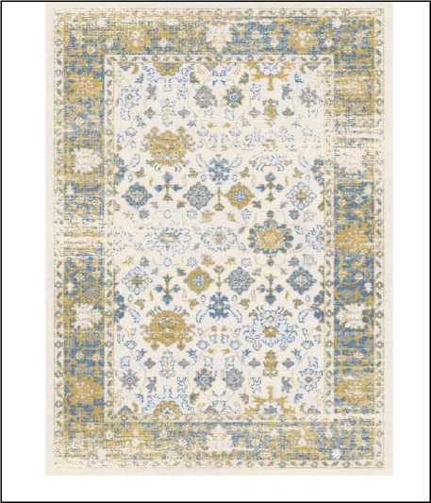

(b) Kesetan (doormat)

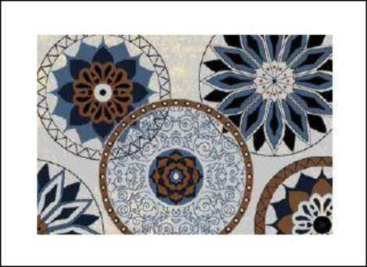

(c) Karpet Dapur (Kitchen Mat)

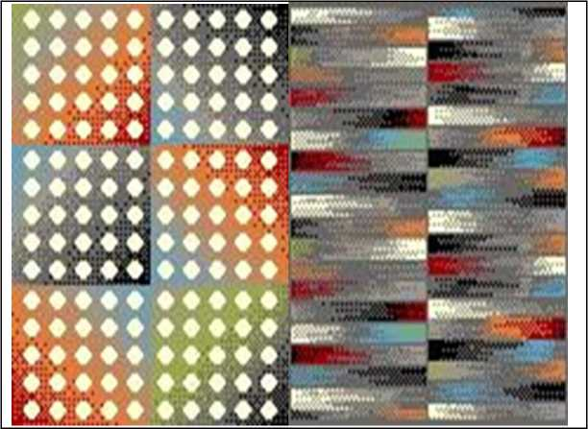

(d) Karpet Wall to Wall (Wall to Wall carpets rolls)

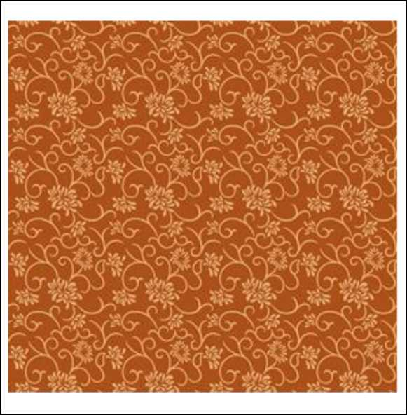

(e) Karpet Tile

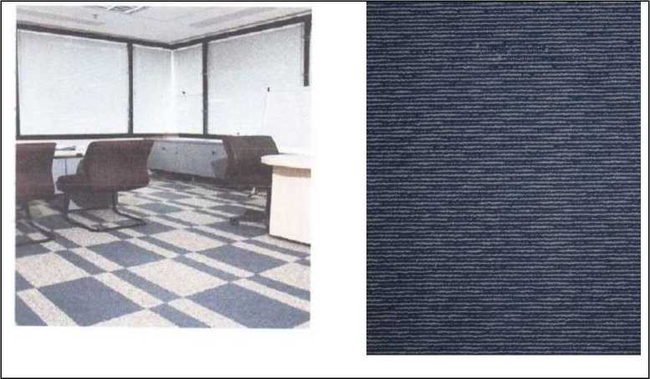

(f) Sajadah Rol (Prayer Rugs in rolls)

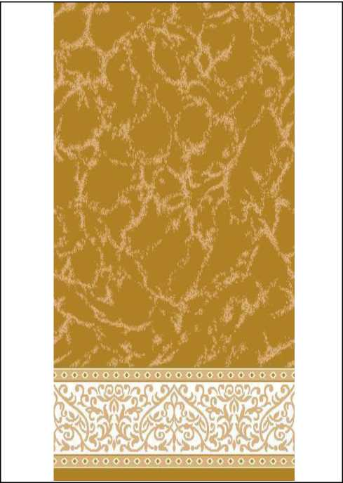

**(g) Sheet prayer rug**

(h) Hambal (Carpet)

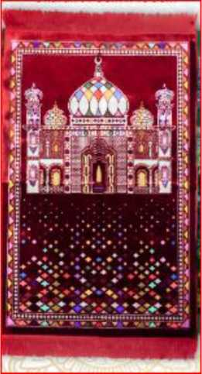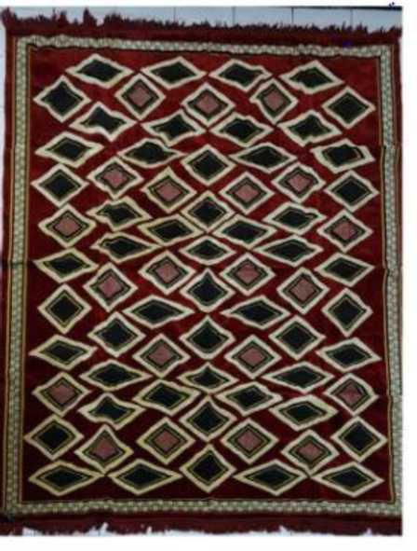

(i) Artificial Grass Carpet

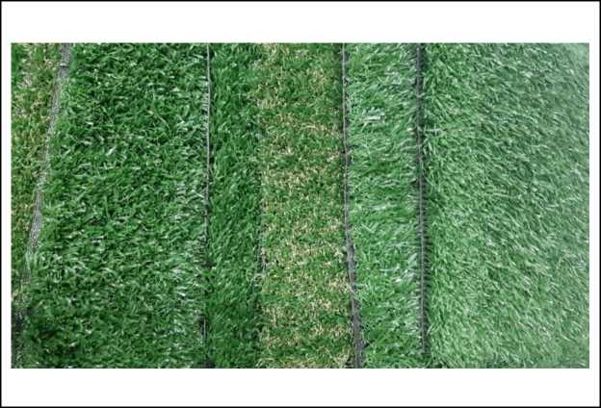

(j) Automotive Carpet

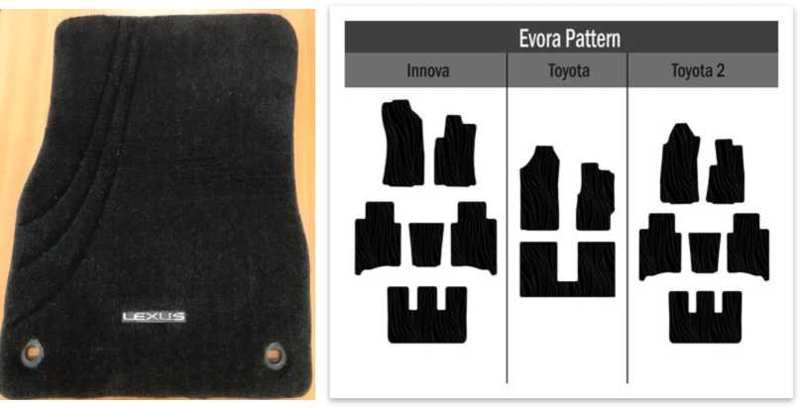

All types of carpets as above can be produced with various sizes and thicknesses or can be produced to order.

1. **Imported Goods**

The physical characteristics of carpets and other imported floor covering textiles are exactly the same as those produced by the Applicant.

1. Usability of Goods

The goods produced by the applicant have the following uses:

1. **Goods produced by the applicant**

The use of carpets can be used to define a space, this will be very beneficial in open spaces including living rooms, sitting rooms, dining rooms and other spaces that are sometimes present without partitions.

Use Carpets can also be used as an interior in a room that can reduce noise, prevent air pollution, provide a sense of warmth, comfort and words between families when lying on the floor of a carpeted room. Carpets are used for housing, apartments, offices, restaurants, hotels, projects, airports and cinema halls.

Modifications to the type of carpet that is now widely used are tile carpets resembling tiles / tiles with a rubber base layer in the form of sheets. This Tile carpet is not only for comfort but also for aesthetics because it can be arranged parallel and can also be arranged vertically horizontally, so that it looks a pattern that can beautify the room. In addition, carpet tiles / tiles facilitate replacement when there are certain parts that are damaged or dirty do not need to replace all, just certain parts are damaged / dirty, easy for other installations such as electrical cables and others, easy to transport in tall buildings, maintain room temperature and add to the aesthetics of a building.

For this type of artificial grass carpet is quite practical because it can be placed in the yard of the house and can be installed on the sports field as a substitute for natural grass. Carpets are also commonly used for automotive / vehicles as a base to dampen sound and aesthetics and comfort.

A carpet like a prayer mat is an object that every house has, especially Muslims. Prayer mats are usually used as a base for prayer, both prayers carried out in homes, in mosques and carried out in the field during holiday prayers by providing a sense of tenderness, comfort, and solemnity in worship.

1. **Imported Goods**

The usefulness of imported carpets and other floor covering textiles is the same as that produced by the Applicant.

1. Raw Materials

The goods produced by the Applicant have raw materials, as follows:

1. **Goods produced by the applicant**

The raw materials used by the Applicant to produce carpets and other floor covering textiles are derived from *polypropylene, polyester, nylon, poly acrylic*, wool, *cotton*, PE, *acrilyc*, TC, jute and synthetic yarn and other yarns. The layers used are latex, the first layer (Primary Carpet Backing*), the second layer (*Secondary Carpet Backing*) in the form of* action back*, non-slip rubber, Non woven felt, SBS, TPR, and PVC.*

1. **Imported Goods**

The raw materials of imported goods are generally the same as the raw materials used by the Applicant to produce carpets and other floor covering textiles

1. **Statement of Similar Goods or Goods that Directly Compete** Article 1 points 10 and 11, PP No. 34 of 2011 states that similar goods are domestically produced goods that are identical or the same in all respects as imported goods or goods that have characteristics resembling imported goods. Directly Competing Goods are domestically produced goods that in their use can replace the goods under investigation.

Based on the explanation presented in numbers 2-4 above, the Applicant believes that carpet goods and other floor covering textiles produced by the applicant are **similar goods** or  **goods that directly compete** with imported goods, because they have similarities in physical characteristics, raw materials and uses.

1. **INFORMATION ON THE SURGE IN THE NUMBER OF IMPORTED GOODS**
2. **Import Amount**

Table 3: Quantity of imports of goods requested for protection (absolute &; relative)

|  |  |  |  |  |
| --- | --- | --- | --- | --- |
| **Description** | **Unit** | **Year** | | |
| **2020** | **2021** | **2022** |
| Import Amount | Ton | 3.329 | 1.848 | 5.004 |
| Change | % |  | (44,51) | 170,85 |
| Import Trends | % | 22,60 | | |
| National Production | Index | 100 | 105,11 | 99,88 |
| Relative Import | Index | 100 | 52,81 | 150,50 |
| Change | % |  | (47,19) | 184,96 |
| Relative Import Trends | % | 22,68 | | |

Source: Central Bureau of Statistics (BPS), association member data, and Applicant

Based on the data in table 3 above, the number of imports of Goods Investigated in Absolute Terms initially decreased from 2020 by 3,329 tons to 1,848 tons in 2021, but in 2022 the number of imports increased to 5,004 tons. The trend of a surge in the number of imports of Goods

Investigated in absolute terms during 2020-2022 is 22.60%.

Then based on the data in table 3 above, the number of imports of Goods Investigated initially decreased to national production, namely in 2020 by 100 index points to 52.81 index points in 2021, but there was a fairly high jump in 2022 to 150.50 index points.

The trend of increasing the number of imports of Goods Investigated relative to national production during 2020-2022 is 22.68%.

1. **Import Share**

Table 4: Share of Import Country of Origin

|  |  |  |  |  |  |  |  |
| --- | --- | --- | --- | --- | --- | --- | --- |
| **No** | **Country of Import Origin *)** | **2020** | | **2021** | | **2022** | |
| **Volume (Ton)** | **Share (%)** | **Volume (Ton)** | **Share (%)** | **Volume (Ton)** | **Share (%)** |
| 1 | VIETNAMESE | 13 | 0,40 | 0,01 | 0,00 | 2.017 | 40,30 |
| 2 | TURKISH | 493 | 14,82 | 207 | 11,22 | 1.475 | 29,48 |
| 3 | MALAYSIA | 248 | 7,44 | 605 | 32,72 | 498 | 9,96 |
| 4 | JAPANESE | 420 | 12,62 | 524 | 28,34 | 362 | 7,23 |
| 5 | REPUBLIC  CHINA (PRC) | 701 | 21,06 | 294 | 15,89 | 313 | 6,26 |
| 6 | THAILAND | 112 | 3,35 | 32 | 1,74 | 159 | 3,17 |
| 7 | OTHER COUNTRIES | 1.342 | 40,31 | 186 | 10,09 | 180 | 3,60 |
|  | **World** | **3.329** | **100,00** | **1.848** | **100,00** | **5.004** | **100,00** |

Source: Central Bureau of Statistics, processed

As seen in table 4 above, the largest import origin countries in 2022 are Vietnam with an import market share of 40.30%, followed by Turkey with an import market share of 29.48%, Malaysia with an import market share of 9.96%, Japan with an import market share of 7.23%, the People's Republic of China (PRC) with an import market share of 6.26% and Thailand with an import market share of 3.17% and other countries below 3% with an import market share of 3.60%.

1. **APPLICANT LOSS INFORMATION**

Table 5: Applicant Performance Indicators

|  |  |  |  |  |  |  |  |  |
| --- | --- | --- | --- | --- | --- | --- | --- | --- |
| **NO.** | **DESCRIPTION** | **Unit** | **Year** | | | **Change (%)** | | **Trend (%)** |
| **2020** | **2021** | **2022** | **20/21** | **21/22** | **20-22** |
| 1 | Production | Index | 100,00 | 102,89 | 99,71 | 2,89 | (3,10) | (0,15) |
| 2 | Domestic Sales | Index | 100,00 | 104,51 | 97,23 | 4,51 | (6,97) | (1,40) |
| 3 | Productivity | Index | 100,00 | 111,34 | 110,75 | 11,34 | (0,53) | 5,24 |

|  |  |  |  |  |  |  |  |  |
| --- | --- | --- | --- | --- | --- | --- | --- | --- |
| 4 | Used Capacity | Index | 100,00 | 102,89 | 99,71 | 2,89 | (3,10) | (0,15) |
| 5 | Advantages / Disadvantages | Index | 100,00 | 51,13 | 51,20 | (48,87) | 0,13 | (28,45) |
| 6 | Workforce | Index | 100,00 | 92,41 | 90,03 | (7,59) | (2,58) | (5,12) |
| 7 | Ending Inventory | Index | 100,00 | 97,60 | 109,40 | (2,40) | 12,08 | 4,59 |
| Sum | ber: Applicant | | | | | | | |

The following is an explanation of the Applicant's IDN performance indicators:

1. Production

The applicant's production volume has increased from 100 index points in 2020 to 102.89 index points in 2021. Although it increased during 2020-2021, in the following year the production volume decreased to 99.71 index points in 2022 from the previous 102.89 index points in 2021.

During the period 2020-2022, the Applicant's production volume decreased with a trend of 0.15%. The decrease in production volume occurred due to a decrease in demand for applicant products when imported goods filled the Indonesian market.

1. Domestic sales

Applicants' Domestic Sales increased from 100 index points in 2020 to 104.51 index points in 2021 and again decreased to 97.23 index points in 2022. During the period 2020-2022, Applicant's domestic sales decreased with a trend of 1.40%. The decline in domestic sales was due to the pressure of imported goods that flooded the Indonesian market.

1. Productivity

Applicant productivity in 2020 was 100 index points, while in 2021 productivity increased by 111.34 index points but in the following year in 2021 productivity decreased slightly to 110.75 index points. During the 2020-2022 period, there was a trend of increasing productivity by 5.24%. The increase in productivity is due to the decrease in the number of workers affected by the increase in imported goods.

1. Used Capacity

The Applicant's Used Capacity has increased by 100 index points in 2020 to 102.89 index points in 2021. The applicant increased production in 2021 because domestic carpet consumption was very large and increased from year to year while in 2022 used capacity decreased to 99.71 index points due to *decreased demand* due to increased imports. During the period 2020-2022, the Applicant's installed capacity of 100 index points is capable of production to meet local demand and avoid imported goods products flooding the Indonesian market.

1. Advantages/Disadvantages

In 2020 the Applicant's profit was 100 index points, but in 2021 it decreased its profit to 51.13 index points and in 2022 it increased slightly by 51.20 index points but still lower than the profit in 2020. During the 20202022 period the Applicant experienced a decline in profits with a trend of 28.45%.

1. Workforce

Applicants lowered the workforce from 100 index points in 2020 to 92.41 index points in 2021. In 2022, there was a decline in the number of workers again to 90.03 index points. The Applicant was forced to lay off the workforce for efficiency due to decreased performance due to the onslaught of imported goods and was forced to stop production machinery due to a decrease in orders from customers who switched to buy similar imported products or compete with the Applicant's products.

1. Ending inventory

In 2020 the applicant's final inventory was 100 index points and then experienced a reduction in inventory in 2021 to 97.60 index points. However, then in 2022, final inventory increased to 109.40 index points due to declining sales and goods circulating in the market were imported goods so that the portion of market share was taken over by imported products.

1. **MARKET SHARE**

Table 6: Home Market Conditions

|  |  |  |  |  |  |  |  |  |
| --- | --- | --- | --- | --- | --- | --- | --- | --- |
| **NO** | **DESCRIPTION** | **Unit** | **Year** | | | **Change (%)** | | **Trend (%)** |
| **2020** | **2021** | **2022** | **20/21** | **21/22** | **20-22** |
| 1 | Consumption  National | Index | 100 | 107,99 | 112,68 | 7,99 | 4,34 | 6,15 |
| 2 | Applicant's Domestic Sales | Index | 100 | 104,51 | 97,23 | 4,51 | (6,97) | (1,40) |
| 3 | Sales  Domestic Non Applicant | Index | 100 | 138,35 | 150,29 | 38,35 | 8,63 | 22,59 |
| 4 | Import Amount | Ton | 3.329 | 1.848 | 5.004 | (44,51) | 170,85 | 22,60 |
| 5 | Applicant Market Share | Index | 100 | 96,78 | 86,29 | (3,22) | (10,84) | (7,11) |
| 6 | Non Applicant Market Share | Index | 100 | 128,11 | 133,38 | 28,11 | 4,11 | 15,49 |
| 7 | Import Market Share | Index | 100 | 51,39 | 133,40 | (48,61) | 159,58 | 15,50 |

Source: Indonesian Textile Association, IDN and BPS, processed

The market share of Applicants, which was originally 100 index points in 2020, decreased to 96.78 index points in 2021 and the Import market share in 2020 of 100 index points decreased to 51.39 index points in 2021. However, in 2022, the market share of Applicants has decreased, namely by

86.29 index points amid the import market share which continues to increase to 133.40 index points. During the period 2020-2022, the market share of Applicants decreased with a trend of 7.11%, while the Import market share experienced an increase in trend of 15.50%.

1. STRUCTURAL ADJUSTMENT

Since the enactment of BMTP based on the Minister of Finance Regulation (PMK) Number 10/PMK.010/2021 concerning the Imposition of Import Duties on Security Measures on Imports of Carpet Products and Other Floor Covering Textiles, the Applicant has made several structural adjustments in accordance with the commitments in the program plan contained in the final report of the results of the investigation of trade security measures against the import of carpet goods and other floor covering textiles as for the status of its implementation can be Illustrated in the following table:

Table 7: Realization of Structural Adjustment Implementation

|  |  |  |  |  |
| --- | --- | --- | --- | --- |
| **No.** | **Action Plan** | **Stages of Action** | **Status** | |
| **Realized (%)** | **Unrealized (%)** |
| 1 | Increase system  technology production  by way of buying a machine with the most advanced model, and  change machine-  Old machines become newer machines so that production can be more efficient. | Search for information related to high efficiency and productivity machines. | 76,67 | 23,33 |
| Making a purchase of a new machine. | 71,11 | 28,89 |
| Perform the installation and the new machine starts operating. | 54,44 | 45,56 |
| 2 | Do Innovation  product with  adding product variations, and  improve product quality to  Grow sales worth  add. | Conduct research to create samples of new goods that are acceptable in the market. | 75,00 | 25,00 |
| Develop samples of new goods and conduct testing to the market. | 58,33 | 41,67 |
| Start production of high-quality new goods that have been well received in the market. | 58,33 | 41,67 |
| 3 | Human Resource Development with give  Training deep  in order to improve the skills and performance of the workforce. | Training on the operation of new machines by bringing in trainers from abroad. | 26,67 | 73,33 |
| Do  Remedial Training | 30,56 | 69,44 |

|  |  |  |  |  |
| --- | --- | --- | --- | --- |
|  |  | new technology machines. |  |  |
| Increase the amount of employee training to improve their skills. | 68,33 | 31,67 |
|  | **Average** |  | 57,72 | 42,28 |

Source: Applicant

The percentage value of implementation can be described as follows:

1. Improve the production technology system by purchasing machines with the most advanced models, and replacing old machines into newer machines so that production can be more efficient.
2. Search for information related to high efficiency and productivity machines.

In improving the technology system, it must look for information related to high efficiency and productivity machines which have been realized 76.67%

1. Purchasing new machines has been realized 71.11% and has not been realized 28.89%
2. Installing and starting to operate new machines have been realized 54.44% and 45.56% have not been realized because the installation and operation of new machines requires the arrival of foreign technicians to provide exposure and training for operators and some spare parts sent have not yet arrived.
3. Innovate products by adding product variations, as well as improving product quality to develop value-added sales in quality, functionality, or attractiveness to customers.
4. Conduct research to create samples of new goods that are acceptable in the market. The company has carried out product development, namely anti-bacterial carpets and changes or improvements in aesthetic aspects where 75.00% has been realized.
5. Develop samples of new goods and conduct testing to the market. In order to produce a completely new product and create major changes to the industry or society, the Applicant has conducted testing to the domestic market which has been realized 58.33% and has not been realized 41.67% because it still requires time and research and training for workers who have good competence. However, this is hampered because workers who have the potential to require greater expenditure and the Company's condition is currently in the recovery stage and the domestic industrial market is still flooded with products that are not domestically produced.
6. Start production of high-quality new goods that have been well received in the market. Launching new products that have uniqueness, or added value that can satisfy consumers with high-quality products but the price is more affordable with realization of 58.33% and 41.67% has not been realized.
7. Human resource development by providing training in order to improve the skills and performance of the workforce.
8. Training on the operation of new machines by bringing in trainers from abroad has been realized 26.67%. The unrealized amounted to 73.33% because in the imposition of BMTP in the first year, it was difficult to bring trainers from abroad due to the Covid-19 pandemic.
9. Conduct training on repair of new technology machines. We have not been able to conduct training from experts because the new machine has not been fully installed and has not been operational. So that the new realization amounted to 30.56%.
10. Increase the amount of employee training to improve their skills. There is no training from experts but we conduct training programs conducted by senior trainers regularly, which have been realized 68.33% and unrealized 31.67%

The total achievement of the applicant's structural adjustment is 57.72%, there are several structural adjustments that have not been realized. Based on this, the structural adjustment program but there are obstacles so that there are things that have not been optimally carried out by the Applicant. Due to the large number of imported carpets and other floor covering textiles, it still has an influence on the suboptimal implementation of the structural adjustment program which is the cause of the delay in the recovery of the Applicant's losses.

1. REQUEST FOR INVESTIGATION INTO EXTENSION OF TRADE SECURITY MEASURES

In connection with the non-recovery of serious losses or the threat of serious losses suffered by the Applicant from 2020-2022 as described in table 5 (performance indicators) and the still incomplete structural adjustments as described in table 7, the Applicant requests the Government of the Republic of Indonesia to extend the imposition of BMTP on the importation of imported carpets and other floor covering textiles.

1. WILLINGNESS TO COOPERATE

The applicant is willing to cooperate fully throughout the investigation process regarding the filing of an application in the context of the extension of the Imposition of Trade Security Measures on the import of carpet goods and other floor covering textiles

Jakarta, 15th August 2023

**Indonesian Textile Association**

**Jemmy Kartiwa**

Chairman

Appendix 1.

Name and Address of the Importer

1. **PT. SONIA IMPEX**

JL. JATINEGARA BARAT NO.120 RT/RW 017/002 KAMPUNG MELAYU EAST JAKARTA

1. **PT. INDOWARCO JAYA**

JL. KH. MAS MANSYUR NO.44F KEL. KEBON MELATI KEC. TANAH ABANG, JAKARTA

1. **PT. MIGHTY NORTHWEST**

RUKO ENGGANO MEGAH NO.9T JL. ENGGANO RAYA TANJUNG PRIOK, NORTH JAKARTA

1. **PT MASTER MAT INDONESIA**

JL. KETUPA NO. 40 RT. 005 RW. 009 KETABANG, GENTENG, SURABAYA, EAST JAVA

1. **CV.DIAMOND CORE LIGHT**

JL. NORTH SUNTER LAKE KAV.60 BLOCK A. NO.10 KEL. SUNTER AGUNG KEC.

1. **PT. KENCANA SUMBER INTAN**

ALAMANDA TOWER LT.25 WORKSTATION 03, JL TB SIMATUPANG KAV.23-24, JAKSEL

1. **PT. YASHA PRATAMA INDONESIA**

JL. CIPEDES TENGAH NO. 170, KEL. CIPEDES, KEC. SUKAJADI, BANDUNG CITY

1. **CV. GREENWICH INTERNATIONAL**

JL. SEMARANG INDAH BLOCK B-VII NO.1, TO. TAWANGMAS, WEST SEMARANG, SEMARANG

1. **PT. SON OF ASAHAN JAYATRANS**

JL. MERBAU NO. 2-J, SEKIP VILLAGE, MEDAN PETISAH SUB-DISTRICT

1. **CV MITRA PERKASA**

SHOPHOUSE MUTIARA MARINA KAV 2F, TAWANGSARI, SEMARANG, CENTRAL JAVA

1. **JAYA ABADI MAS**

JL. IN PANJAITAN NO. 14 BYPASS, EAST JAKARTA, ZIP CODE 13350

PHONE: 021-85915988, 021-8196849, FAX: 021-8198976

Appendix 2.

Name and Address of the Exporter

1. **OZAKBULUT TEXTILE INSAAT SAN VE DIS TIC**

ATATURK MAH. YILDIRIM BETAZIT CAD. ERTAS SOK NO.32

1. **TIANJIN SHENGRONG TEXTILE CO., LTD**

WEST 500, CUIHUANGKOU, WUQING, DISTRICT, TIANJIN,

1. **KARADENIZ MENSUCAT SAN VE TIC LTD**

STI IKITELLI ORG SAN BOLGESI BIKSAN KOOP B1 BLOCK

1. **SUZHOU UNIVERSE IMPORT AND EXPORT CO.**

ROOM 1301, BLOCK 1, NO. 309 ZHENGHE ROAD, CHENGXIA

1. **TIANJIN JIACHUAN CARPET CO., LTD**

BEIXINZHUANG VILLAGE, CUIHUANGKOU TOWN, WUQING DIS

1. **HUITAI TEXTILE CO., LTD.**

NO.3 XINAN ROAD, FOTANG TOWN INDUSTRIAL PARK, YIWU

1. **JIANGSU KINGDAY TEXTILE CO. LTD.**

WEIWU ROAD LIANSHUI ECONOMIC DEVELOPMENT ZONE HUAI

1. **BEDIROGLU TEXTILE IML.ITH. SAN VE TIC. LTD.**

HICRET MAH. YILDIRIM BEYAZIT CD.NO:165/1 BOLLUCA-

1. **SAHAN IC VE DIS TIC. LTD.. ST.**

5.ORG. SAN. BOL.83 536 NOLU CAD.NO:3 BASPINAR

1. **HEBEI YAAO TEXTILE CO., LTD**

WEST OF LIUHETUN VILLAGE XINGNAN RURAL AREA GAOYAN

1. **WUXI DIAMOND CARPET MANUFACTURING CO., LTD.**

NO. 28 NONGSHI ROAD, NONGBA INDUSTRIAL PARK, DONGBEITANG, WUXI POSTAL CODE: 214191.

1. **SHEN ZHEN TAI PING CARPETS**

1ST QIANJIN ROAD, BAO AN INDUSTRIAL ZONE, SHENZHEN,CHINA.

Appendix 3.

Name and Address of the Importer's Association

**1. GINSI (Association of National Importers throughout Indonesia)**

Jl. Raya Kelapa Nias No.27, RT.1/RW.12, Pegangsaan Dua, Kec. Klp. Gading, North JKT, Capital City of Jakarta Special Region 14240